WHAT DOES A HIGH PERFORMANCE COACH DO?
May 21, 2020
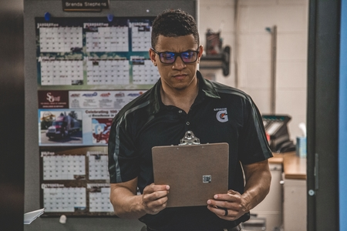
Michael Jordan didn’t initially make it onto his high school varsity basketball team. Tom Brady wasn’t a first round draft pick out of college (in fact, he was the 199th pick). In addition to a high level of talent and dedication, these sports mega stars attribute much of their success to excellent athletic coaching.
High performance coaches are, after all, commodities in their own right. Olympic coach Glen Mills has been hailed as “the man behind Usain Bolt’s record shattering career.” As stated in an article from The Telegraph, Mills strived to develop an innate understanding of things like agility, coordination, anatomy, and talent identification.
Successful high performance coaching is about more than just balancing the win-loss record—it’s about the holistic development of your players.
Former U.S. Olympic and NCAA swimming coach James “Doc” Counsilman noted the importance of implementing a positive, athlete-centered coaching style, which included helping his athletes set realistic goals and build confidence.
High performance sports coaching can be a literal game changer for the athletes that are being trained. We highlight why as we go more in-depth about the high performance coaching profession below.

WHAT DO HIGH PERFORMANCE COACHES DO?
High performance coaches can be distinguished from regular coaches by their approach to training. These coaches use an integrated approach that includes a combination of physical, mental, and psychological training. The conception is that these coaches only work with elite athletes, but that isn’t the case. High performance coaches work with different levels of athletes, helping them play at their best, both individually and (when applicable) with a team. Effective coaches also work with athletes to develop a series of short-term goals—for example, shaving time off a run or swim.
High performance coaches combine physiology, kinesiology, and psychology in their training and often serve as role models, mentors, teachers and community leaders. They also work with a team of specialists that include physiotherapists and nutritionists. In addition, high performance coaches make sure their athletes have access to the best resources and equipment available.
Coaches have a diverse list of responsibilities when it comes to taking care of their athletes, including communication, injury prevention, risk management, goal setting, athlete development and nutrition.

HOW TO BECOME A HIGH PERFORMANCE COACH
According to the U.S. Bureau of Labor Statistics, sports scouts and coaches usually need a bachelor’s degree, as well as extensive knowledge of the particular sport they are coaching. This knowledge can be gained through experience and programs specifically targeted for coaching high performance athletes, like University of Florida’s online master’s in sport management with a specialization in High Performance Coaching. One thing to look for in a high performance coaching program is a well-rounded curriculum. UF’s program includes the following coursework:
- Nutrition
- Energy Systems
- Physical Training
- Athlete Fitness
- Athlete Health and Safety
- Psychology and Mental Skills
- Athlete Maturation
In addition to it being a sought after career choice, the need for athletic coaches is growing. The BLS reports that coach and scout careers are projected to grow much faster than the average between 2018 and 2028. The median salary is $38,640.

TRAITS OF AN EFFECTIVE COACH
Each coach brings their own unique set of qualities to the table. That said, there are certain traits that many of these coaches have in common. According to the International Olympic Committee, these are the some of the traits of a great coach:
- Leads by example
- Knows the athlete well, and respects and values the relationship
- Has a good understanding of the sport
- Is a profound thinker and visionary
- Educates others and shares knowledge
- Effectively communicates and teaches
- Demonstrates good listening skills
- Energizes and motivates athletes and other coaching staff
- Has strong character, discipline and integrity
- Displays passion for the sport

WHERE DO HIGH PERFORMANCE COACHES WORK?
High performance coaches might have several different titles, including head coach, associate head coach, sports administrator, and strength and conditioning coordinator. They often work in high schools, colleges, professional sports, competitions and travel teams.
Though these coaches may not officially use the high performance coach moniker, anyone who trains their athletes using an integrated approach falls into the category. These individuals work in an array of environments, from high school sports teams to one-on-one with elite athletes.

CREDENTIALS THAT CAN BE EARNED TO FURTHER A HIGH PERFORMANCE COACHING CAREER
Coaches who are interested in managerial or more specialized positions can benefit from additional training in the field. Master’s degrees in sport management or high performance coaching are an excellent way to increase your knowledge and stay competitive. An advanced degree gives you access to the most recent trends and research in the industry, and improves your communication and leadership skills.

