10 Ways to Promote Sportsmanship
January 21, 2020
View all blog posts underArticles | View all blog posts underOnline Master of Athletic Administration
When it comes to coaching, first and foremost a coach should encourage good sportsmanship. Especially when coaching children, it is important for coaches to remember that children look to coaches as role models. Coaches must impart positive values to children along with rigorous athletic training. Coaches need to promote high standards of integrity while supplying a team-first atmosphere. Ensure that the focus is on learning important skills both on and off the field while also working towards a common goal.
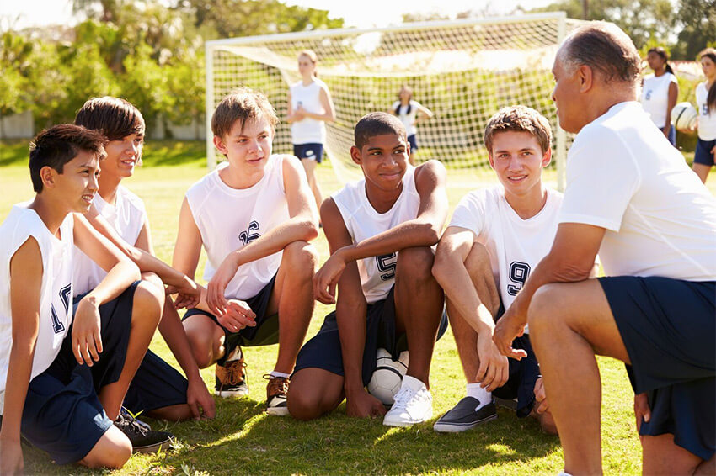
Remember that young eyes are always watching, therefore coaches should serve as role models by promoting good sportsmanship to promote positive child development. Sports can promote values such as respect, discipline, and commitment. These sportsmanship values are just as important as the development of athletic prowess. Sometimes, it can be challenging to marry sportsmanship and athletic success. There are several important pieces of advice that all coaches should keep in mind when working to promote sportsmanship.

1. Promote Integrity
Most people have experienced the discomfort that comes with competing against someone who sacrifices integrity in the name of victory. When it comes to young athletes, promoting integrity should remain at the forefront of every athletic competition. Therefore, a coach should encourage a team to always play within the rules. Never encourage athletes to perform morally or legally questionable actions during gameplay. Furthermore, if a call goes the way of your team when you are certain that it should go in favor of the other team, step up and say so. Set a positive example for athletes by preserving integrity as the highest priority. By setting a positive example, athletes will learn to respect the game instead of trying to win by sacrificing morals. Encouraging integrity on the field will also translate to positive character development off of the field.

2. Minimize Selfish Actions
A coach should work to minimize braggadocios behavior. Do not allow athletes to get away with taunting or showboating for big plays. The NFL is a perfect example of a professional sports organization cracking down on disrespectful celebration. These celebrations include using props, such as cell phones and footballs, offensive gestures, and group celebrations. While kids take after professional athletes who may behave this way, remind children that they should celebrate in a responsible and respectful manner. A neutral gesture, such as the Cam Newton Superman pose, is acceptable, but disparaging celebrations go too far. Encourage players to focus on team success and respectful celebration instead of offensive or choreographed group celebrations.

3. Respect Referees
It is common for children to see professional athletes confronting referees and officials for calling fouls, strikes, and penalties. When kids look around the stands, they may even see parents going after refs. While children may want to follow in these actions, remind children that officials are there to encourage fairness to all players while protecting the players on the field. Encourage players to address concerns with referees in a way that doesn’t embarrass the referee. This includes avoiding offensive language or gestures directed at officials. Players should start by approaching refs with a calm question that does not accuse the ref of bias. Coaches should remind players that this has a higher chance of having their concerns addressed. Coaches should remember to set a positive example for players in their own interactions with refs. Use a neutral tone when addressing referees that show players how to communicate their point respectfully to officials.

4. Encourage Teamwork
One of the most important aspects of sports is the development of teamwork. Whether in sports or in life, kids need to learn to work with others to achieve a common goal. Make sure to positively reinforce these values by encouraging the players to work together. Encourage players to help their teammates who might be struggling or to work with kids who might be left out. Children often make mistakes both on and off the field. While correcting mistakes is important, it is vital that coaches do not embarrass players by calling them out individually. Instead, reinforce the idea that the team both succeeds and fails together. By communicating this point, the players will develop essential life skills that are useful both on and off of the field.

5. Focus On Learning
While the result of games is important, the positive life lessons that kids take away from sports are even more important. Sports are important for teaching hand-eye coordination, handling a loss with grace, working with other people, and promoting perseverance. The vital work habits mentioned above, such as discipline, time management, and commitment, are important to reinforce during the course of a season. Kids tend to focus on the result of games, just as adults do. Try to keep their focus on learning important life habits through their participation in sports. Encourage the children to grow personally as well as work hard for wins.

6. Compliment The Other Team For Great Plays
To encourage respect for the opponent, compliment players on the other team for great performances. Everyone is capable of showing respect for an impressive demonstration of athleticism even if it comes against their team. If an outstanding catch is made or amazing teamwork is displayed, be sure to point this out to players on the other team. This will encourage a coach’s team to do the same. One team complimenting the other for great plays is one of the ultimate demonstrations of sportsmanship. Make sure to teach kids to respect the other team by complimenting players for good plays.

7. Praise A Player For Hustle
A team cannot have success on every play. It is important to not let children get discouraged by failure. Make sure to praise a player for a great effort even if the result isn’t perfect. If a kid runs hard and almost beats out an infield base hit, compliment their effort. If a basketball player makes an impressive steal yet misses the layup, point out the great defensive play. If a punter lands a punt on the one-yard line and has it roll into the end zone, say it was a nice try. This will help to foster perseverance by promoting children to put forth their best effort at every opportunity. Always giving 100% effort is an important tenant of sportsmanship. Encourage kids to hustle day in and day out.

8. Criticize Constructively and Privately
Sometimes players need to be singled out for poor displays of sportsmanship, lack of effort, or simply constructive teaching moments; however, never call out a player in front of other people. Especially when it comes to children, it is only natural that sometimes their emotions get the best of them or they lose focus and make silly mistakes. Coaches need to control their emotions and avoid yelling at a player in front of the team. This only serves to cause embarrassment. Instead, pull the player aside privately and politely explain what went wrong and how to rectify it in the future. A child will respect that the coach put in the effort to pull them aside privately. This will generate positive rapport for the coach and help a child grow.

9. Show Deference In Victory And Defeat
Regardless of the outcome, the coach should hold his or her head high, be proud of the effort, and always compliment the other team on a good game. Learning to be humble in victory and remain proud during defeat is a tough balance to strike for children. Make sure the players are respectful in the handshake line with the other team at the end of the game and ensure that the players do not celebrate excessively after a win. There is a right and wrong way to handle both victory and defeat. Demonstrate the proper way to do so when the final buzzer sounds. This will encourage the kids to play fairly and enjoy the game simultaneously.

10. Keep It In Perspective
While the game teaches crucial life lessons already discussed, it is also important to remind children that this is just a game. It is appropriate for players to become passionate during practices and during games, but make sure that players have interests outside of sports too. Without a doubt, there are more important issues in life. Remind the athletes that the ability to play this game is a blessing and children should relish the opportunity. It is more important for the kids to leave the playing field learning important life lessons about integrity, teamwork, and good sportsmanship than enjoying a win.
As demonstrated above, there are many different facets to encouraging and maintaining sportsmanship on a team. Coaches must always remember the role that they play in affecting the athletes they lead. From discipline and strategy to teamwork and compromise, every player should look to their coach as a role model to respect. By teaching a team the importance of sportsmanship, they’ll soon understand the role it plays in their life both on and off the field.

Sources:
All-Pro Dad, “10 Ways to Show Sportsmanship”
Teen Life, “Promoting Sportsmanship in Teen Sports”
KidsHealth.org, “Sportsmanship”
Champions of Character.org, “5 Core Values of Sportsmanship”

